**Setting up Google Cloud**

1. 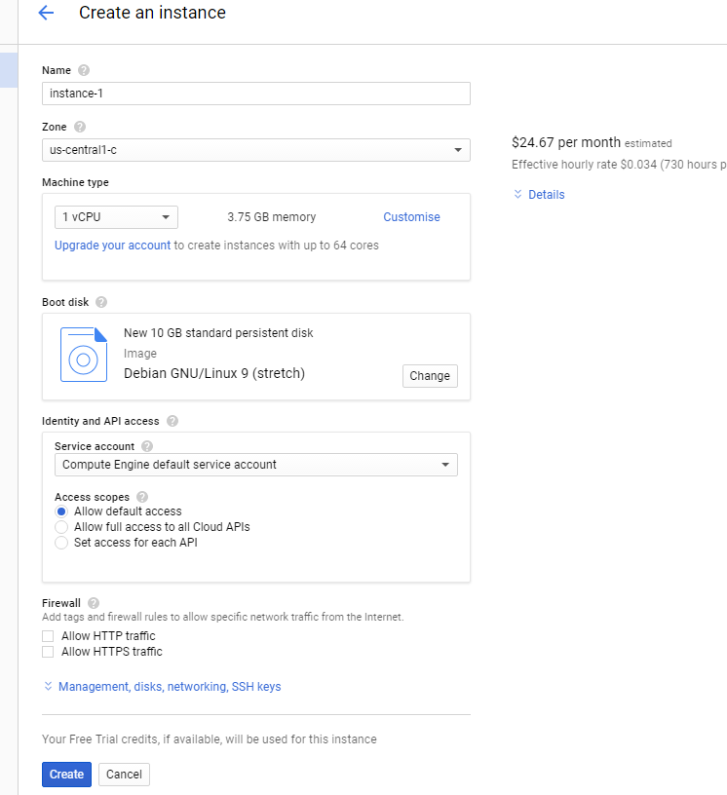Create a Google Cloud account with an existing or new Google Account. ( You may need a Credit Card for this, although its free for the first year. Instructions are pretty much self-explanatory here.)
2. Click on Go to Console
3. On the left pane, you should see a button for Compute Engine. Click on it.
4. In this prompt click on “Create”.
5. You can name your instance whatever you want. Choose a zone according to your region for better results and computation time. You need to choose the number of CPU’s and memory you require for the engine.
6. Choose your Boot Disk (There are various Linux distros available. Choose one. This tutorial will follow through with an Ubuntu system)
7. Click on Create when you are done setting it up. This should take you to “VM Instances” page where you can see all your running instances.
8. Go ahead and Click on the instance that you created, and Click on “Start” on the top pane if it’s not already started up. (Green tick means its running).
9. You should be seeing a field called External IP. This is the IP that we use to connect to this VM remotely. Take note of it.
10. 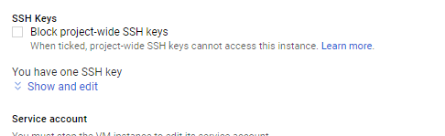Click on Instance name, this should take you to its details page. Click on Edit on the Top pane. Here if you scroll down you should see a field called SSH Keys. Click on Show and edit.

You need to add a Private Key here. (I will take you through on how to get one, on the next page)

**Private Key Creation Using PuttyGen**

1. 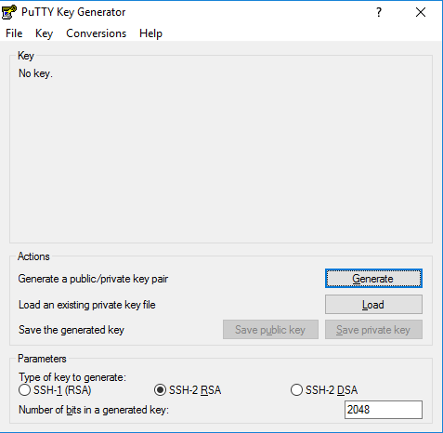Go to this page and follow the instructions to install Putty and PuttyGen in your system: <https://www.ssh.com/ssh/putty/download>
2. Open Puttygen
3. Click on Generate. Now move your mouse in the given field randomly until the bar is filled. (Must be their way of randomizing the keys)
4. 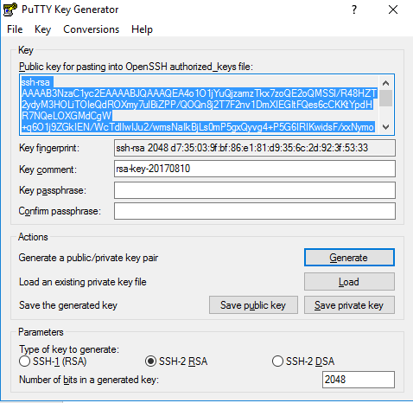When its done you will be prompted with a dialogue box which looks like this:
5. Put the Username you would like in the key comment field. You can add a passphrase too if you want for added layer of security. But it’s not necessary.
6. Once you added the Username and Password copy the text shown in the field and go back into your Instance details page from the previous page and paste the text in the field I mentioned before. If the everything is done correctly then you should see your username popping up to the left of the field.
7. Now click on save in the page, and save the key generated using puttygen as well. We need it for login.
8. I will go through how to login in the next page, using Putty.

**Login to a Shell Session using Putty**

1. Once we have set up the key, the rest is simple.
2. Open Putty and there put in your External IP (Which you copy from your cloud Compute Engine) as the host name. No need to worry about the port now. Do take note of the fact that the IP keeps on changing every time you start a new session on Compute Engine.
3. 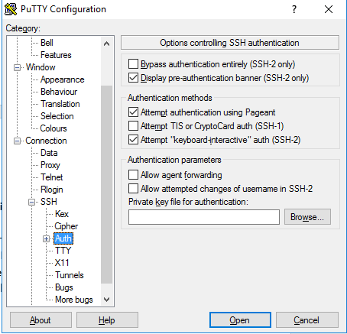On the side pane, you should see a list. Within that list spot SSH (Within connections). There should be an entry call “Auth”. Click on it.
4. Click on browse and locate your private key file which we generated in the previous step.
5. Go back to the previous window where you typed in the host IP, and put your username and password(If you had given a passphrase in the private key file).
6. Now click on Open. If everything is good, then a you should see a Bash Shell. (Same as the one you may find in a Linux/unix System).
7. Here you can type n commands, install stuff and run your scripts using the cloud engine.
8. I will tell you how to transfer files between your compute engine and your local PC in the next page.

**Transferring files using WinSCP**

1. Download and install WinSCP (<https://winscp.net/eng/download.php>)
2. Using the same way as that of Putty you need to enter in the host IP and username and password (if any). Also, don’t forget to browse to your key file and put it in WinSCP. There are similar options on the right pane of WinSCP too. So, it wouldn’t be hard to find the Authentication in this one too.
3. Once everything is setup open the connection and see a window like your windows file explorer.
4. Things are straightforward here. You can drag and drop the files that you want to copy to your cloud engine (It is the one on the right side of the two. Left side is your local machine)
5. Now you are all good to go with cloud engines. Make scripts and queries and use your compute engine to do the job for you a lot quicker.